EXPERIMENT NO. 2 NAME: Mohamed Yahya A
ROLL NO: 240701325

Setting Up a Zoho Creator Account and Exploring the Platform Architecture and Interface

1. Aim:
To set up a Zoho Creator account, create a sample application using forms, reports, and a dashboard, and explore the Develop, Deploy, and Manage sections of the platform.

2. Setting Up Zoho Creator:
I. Create the Sample Application
Procedure:
- Logged in to Zoho Creator.
- Clicked Create New Application.
- Selected From Scratch.
- Entered the application name as Student Management System.
- Clicked Create.
Output:
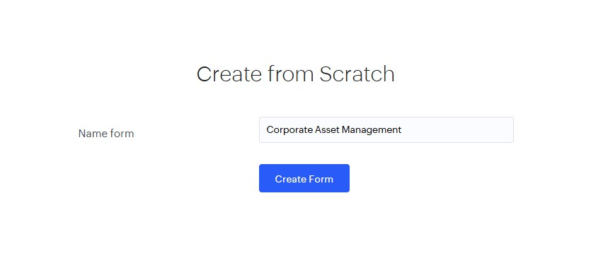

II. Creating Form
Procedure:
- Clicked Create → Form.
- Entered the form name as Student Details.
- Added the required fields such as Name, Roll Number, Department, Email, and Phone Number.
- Saved the form.

Output:
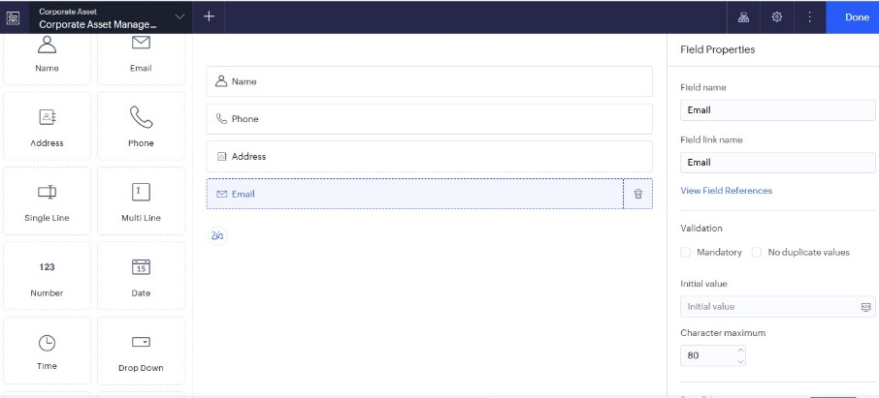

Explanation:
A form is used to collect information from users. It contains various input fields where users can enter data. The submitted data is stored in the application's database.

III. Creating Report
Procedure:
- Clicked Create → Report.
- Selected the Student Details form.
- Created the report and saved it.
Output:
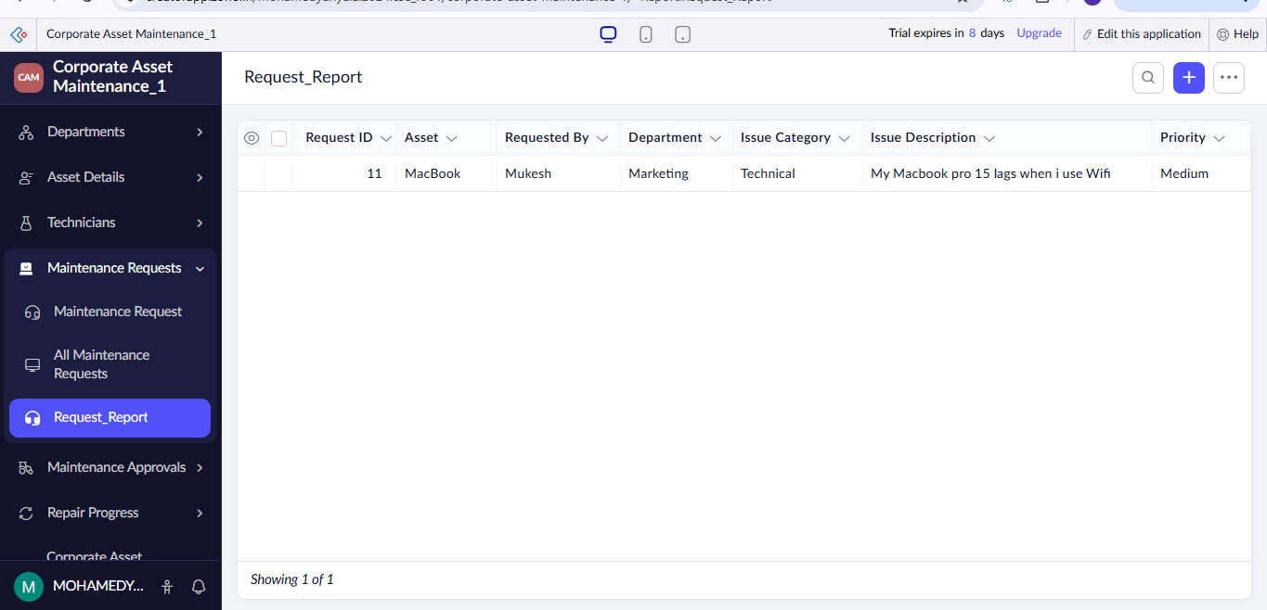

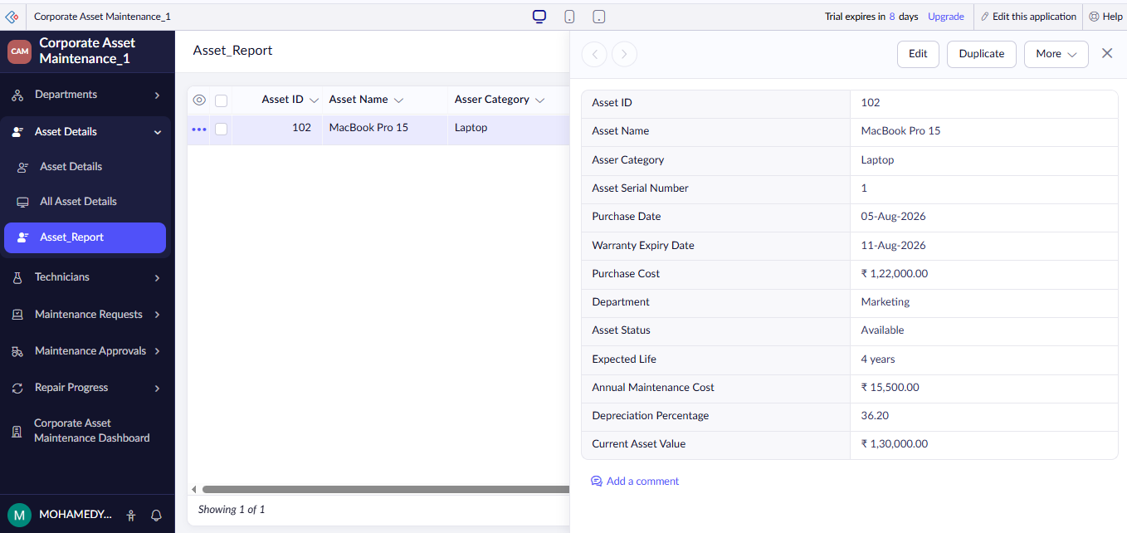

Explanation:
A report displays the records entered through the form. It helps users search, sort, filter, and manage the stored data efficiently.

IV. Creating Dashboard
Procedure:
- Clicked Create → Dashboard.
- Added required report/chart components.
- Saved the dashboard.
Output:
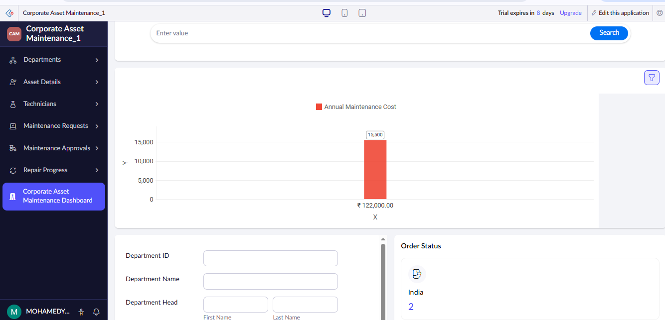

Explanation:
A dashboard provides a graphical overview of application data. It combines reports and charts in a single page, making it easier to analyze information quickly.

3.Exploring the Platform Architecture and Interface:
Develop (Application Creation & Customization):
- Built-in drag-and-drop form and report builders.
- Native Deluge scripting engine for complex business logic.
- Low-code workflow automation for multi-stage approvals.
- Custom HTML/CSS pages for personalized user interfaces.
- Advanced data validation and conditional UI formatting.
- Sandbox environments for development and testing.
Deploy (Application Distribution & Governance):
- Multi-channel publishing across web, iOS, and Android.
- Role-based access control (RBAC) for application security.
- Customer portal provisioning for external user access.
- Version control to track and roll back changes.
- Custom domain mapping for white-labeled applications.
- Single Sign-On (SSO) integration using SAML and Active Directory.
Manage (Administration & Operations):
- Centralized user provisioning and license management.
- Automated data backup with recovery options.
- Integration dashboards for managing APIs and webhooks.
- Audit logs for tracking user activity and data modifications.
- Performance analytics and application health monitoring.
- Data security and encryption management.

4.Result
Thus, a Zoho Creator account was created successfully. A sample application with a form, report, and dashboard was developed, and the Develop, Deploy, and Manage sections of the Zoho Creator platform were explored successfully.

